HKUPSY
Experiment1
Class Analysis (In progress)

Wayne
12/22/2010

Potential Classes
Potential classes are highlighted in the use case descriptions below:
Use Case Name: | DoExperiment
Use Case Number: | #1
Actors: | Subject, Researcher, Time
Description: | Subject does the experiment
Pre-condition: | Subject is prepared for the test
Post-condition: | N/A
Assumption: | Researcher set the experiment mode in the configuration; Subject knows the procedure of the test by practice, and will exactly follow the procedures.
Typical course of events | Actors | System
Typical course of events | Step 1. Initiate the use case when the system is ready for the actor to carry out the experiment, and researcher opens the program.  Step 2. Include use case #3 “Configure”.  Step 7. Include use case #5 “ConductTrial”.  Step 15. Press the spacebar. | Step 6. Open the file with pre-set output filename during the configuration for writing.  Step 5. Write fixed configurations to the output file, including screen height, screen width, screen refresh rate, number of sections, number of trials in each section, total number of trials, subject ID.  Step 6. Include use case #4 “ShowPreTrialScene”.  Step 8. Cancel all bindings on keyboard and mouse.  Step 9. Gather information from the trial and the random object. The information includes the trial ID, object ID, slant, height, rotation speed, tilt, radius, original aspect ratio on z-axis, the aspect ratio on z-axis after subjecting by the subject, texture, and max degree of rotation. Write them to the file using ASCII text.  Step 10. Increase trial ID by 1.  Step 11. Compare current trial ID and max number of trials in one section. If current trial ID is at least max number of trials in one section, increase current section number by 1, and then set current trial ID to 0.  Step 12. Compare current section number with max section number if it is increased by 1.  Step 13. Display a line of string “Experiment finished” on the screen with black background.  Step 14. Bind the spacebar with the function of exiting the program.  Step 16. Close the output file, release used memory, exit the program, and conclude the use case.
Alternative course of events | Step 12. If current section number is at least max section number, go back to step 3.

Use Case Name: | DoPractice
Use Case Number: | #2
Actors: | Subject, Researcher, Time
Description: | Subject does the practice
Pre-condition: | N/A
Post-condition: | N/A
Assumption: | Researcher sets the practice mode in the configuration
Typical course of events | Actors | System
Typical course of events | Step 1. Initiate the use case when the system is ready for the actor to carry out the experiment, and researcher opens the program.  Step 2. Include use case #3 “Configure”.  Step 4. Include use case #5 “ConductTrial”.  Step 13. Press the spacebar. | Step 3. Include use case #4 “ShowPreTrialScene”.  Step 5. Cancel all bindings on keyboard and mouse.  Step 6. Clear the screen with black background. Show the 2D-View of the object using original aspect ratio.  Step 7. Show the 2D-View of the object using the adjusted aspect ratio overlapped with the previous one.  Step 8. Increase trial ID by 1.  Step 9. Compare current trial ID to max number of trials in one section. If current trial ID is at least max number of trials in one section, increase current section number by 1, and then set current trial ID to 0.  Step 10. Compare current section number to the max section number. If it is the current section number is less than the max section number, increase current section number by 1.  Step 11. Display a line of string “Experiment finished” on the screen with black background.  Step 12. Bind the spacebar with the function of exiting the program.  Step 14. Close the output file, release used memory, exit the program, and conclude the use case.
Alternative course of events | Step 10. If current section number is at least max section number, go back to step 3.

Use Case Name: | Configure
Use Case Number: | #3
Actors: | Researcher
Description: | Researcher sets the configuration of the experiment before it starts
Pre-condition: | N/A
Post-condition: | N/A
Assumption: | The experiment scene will not show up until finishing the configuration
Typical course of events | Actor | System
Typical course of events | Step 1. Initiate the use case when the system is started and ready for configuration  Step 3. Set the configurations by filling the blanks, and select the choices. After that, researcher clicks on “Start” button. | Step 2. Show the configuration window. The first line is the blank for the subject ID. The second line is the mode of the experiment, which has two choices, “Experiment” or “Practice”. When “Practice” is selected, the output filename blank is disabled since we do not output the results for practice. The third line is the blank for filling in the number of sections, and number of trials in each section. Show the total number of the trials as well at the end of the line. This number will be updated whenever the number of sections or the number of the trials changes. The fourth line has two choices for selecting the mode of 2D projection. Two choices are available, “orthogonal” and “perspective”. The fifth line is the blank for the output filename. The filename can be automatically changed according to a given rule while any related setting is changed. The default rule is “SubjectID-ExperimentID-DateTime-ExperimentName”. Researcher also can change the filename manually.  Step 4. Validate if all of the blanks are filled in.  Step 5. Validate if the output file has been already existed. If so, pop up a window noticing the output file is existed, and whether to overwrite that file. There are two buttons on the window, One is “yes” meaning overwriting the file, and the other one is “no” meaning not overwriting the file.  Step 6. Initialize the system using the configurations, initialize the glut for later displaying, and end the use case.
Alternative course of events | Step 4. If any blank is not filled in, notice the researcher the missed ones. Then go back to Step 3.  Step 5. If the researcher chooses “no”, go back to Step 3 to let the researcher choose another output filename.

Use Case Name: | ShowPreTrialScene
Use Case Number: | #4
Actors: | Subject
Description: | The system shows “Press spacebar to start the next trial”, and also shows the progress in terms of the sections when the start of each section.
Pre-condition: | There are still trials to do for the subjects
Post-condition: | N/A
Assumption: | N/A
Typical course of events | Actor | System
Typical course of events | Step 1. Initiate the use case after finishing the configuration, or finishing one trial.  Step 6. Conclude the use case, after pressing the spacebar to continue to the next trial. | Step 2. Cancel all binding events on keyboard and mouse, e.g. “Key pressed”, “mouse move”, and so on.  Step 3. Build up the string “Press spacebar to start the next trial”.  Step 4. Check if it is the first trial of the current section. If it is, concatenate the string of progress, e.g. “Current section is 2, total sections is 4, 50% finished”, after the string in Step 3  Step 5. Clear and render the screen with the string. Bind the spacebar with the function of starting the trial.
Alternative course of events

Use Case Name: | ConductTrial
Use Case Number: | #5
Actors: | Subject, Time
Description: | Given original 3D-view of the object, the subject adjusts the aspect ratio on z-axis of the 2D-view of its distorted shape (a random aspect ratio on z-axis) by pressing up arrow and down arrow keys.
Pre-condition: | N/A
Post-condition: | N/A
Assumption: | N/A
Typical course of events | Actor | System
Typical course of events | Step 1. Initiate the use case #4 is finished.  Step 8. Adjust the aspect ratio by pressing up arrow key and down arrow key.  Step 10. Confirm the adjustment by pressing the spacebar. | Step 2. Cancel all binding events on keyboard and mouse, e.g. “Key pressed”, “mouse move”, and so on.  Step 3. Choose a random object from the object base. Set random parameters, including height, initial aspect ratio, tilt, rotation speed, max rotation degree, and texture, to the object.  Step 4. Clear the screen.  Step 5. Render the 3D-view of the object on the left part of the screen. At the first time the object is rendered, the object does not rotate. At i_{th} time the object is rendered, where i > 1, first calculate the time elapsed from the (i-1)_{th} time to i_{th} time, and then calculate the degree need to rotate. If the current rotation degree is larger than the max rotation degree, reverse the rotation direction.  Step 6. Render the 2D-view on the right part of the screen. At the first time, its aspect ratio on z-axis is the same as original aspect ratio.  Step 7. Bind the up arrow key to the function increasing the aspect ratio on z-axis of the object in the 2D-view. Bind the down arrow key to the function decreasing the aspect ratio on z-axis of the object in the 2D-view.  Bind the spacebar to the function of confirming adjustment. This step is only been executed once.  Step 9. Call corresponding functions to adjust the aspect ratio, but do not render it until the screen is refreshed according to the refresh rate.  Step 11. Conclude the use case.
Alternative course of events | Step 8 – 9. The screen is refreshed due to the refresh rate we set, go to step 5 after finish the step.  Step 10. Subject can go back to Step 8 without executing step 10.

Potential Classes in Design Model
In this section, summarize the potential classes again in design model.
Table 1 Potential Classes
Potential Classes | Class type | Class Name
Configuration Window | Boundary | ConfWnd
Screen | Boundary | Screen
Scene | Control | Scene
Experiment | Control | Experiment
Trial | Control | Trial
TestObject | Entity | TestObject

Attributes of each class
Now consider the attributes for each class:
- ConfWnd: N/A
- Screen: N/A
- Scene: N/A
- Experiment:
  - currSecNo (Current section number)
  - maxSecNo (total section number)
  - experiMode (Experiment mode)
  - outFilename (output filename)
  - subjectID (subject ID)
  - trialsInOneSec (number of trials in one section)
  - lineStyleOrg (line style for displaying original object 2D-view)
  - lineColorOrg (line color for displaying original object 2D-view)
  - outFilenameRule (output filename rule)
  - refreshRate (refresh rate of the screen)
  - scrHeight (screen height)
  - scrWidth (screen width).
- Trial:
  - trialID (trial ID)
- TestObject:
  - slant (slant)
  - height (height)
  - tilt (tilt)
  - rotSpeed (rotation speed)
  - proj2DMode (projection mode in 2D)
  - radius (radius of the cylinder, it may not be appear for other objects)
  - objectID (object ID)
  - initZAsptRatio (initial aspect ratio on z-axis)
  - adjZAsptRatio (aspect ratio on z-axis after adjustment)
  - texture (texture for the object in 3D-view)
  - maxRotDeg (max rotation degree. If it is a, then the rotation range is in [-a, a])

Behaviors of each class
I first extract potential behaviors from the use case descriptions, and conclude them in Table 2.
Table 2 Potential Behaviors
Behaviors | Manual/Automated | Class type
Open the file with pre-set output filename | Automated | Control
Cancel all bindings on keyboard and mouse | Automated | Control
Gather information from the trial and random object | Automated | Control
Write fixed configurations | Automated | Control
Write them to the file using ASCII text | Automated | Control
Compare current trial ID and max number of trials in one section | Automated | Control
Increase current section number by 1 | Automated | Control
Set current trial ID to 0 | Automated | Control
Display a line of string | Automated | Boundary
Press the spacebar | Manual
Close the output file | Automated | Control
Release used memory | Automated | Control
Exit the program | Automated | Control
Clear the screen with black background | Automated | Boundary
Show the 2D-view of the object using original aspect ratio | Automated | Boundary
Show the 2D-view of the object using the adjusted aspect ratio | Automated | Boundary
Increase trial ID by 1 | Automated | Control
Compare current section number to the max section number | Automated | Control
Increase current section number by 1 | Automated | Control
Bind the spacebar with the function of exiting the program | Automated | Control
Show the configuration window | Automated | Boundary
Disable the output filename blank | Automated | Boundary
Show the total number of the trials | Automated | Boundary
This number will be updated whenever the number of sections or the number of the trials changes | Automated | Boundary
The filename can be automatically changed according to a given rule while any related setting is changed. | Automated | Boundary
Research also can change the filename manually | Manual
Set the configurations | Manual
Select the choices | Manual
Clicks on “Start” button | Manual
Validate if all of the blanks are filled in | Automated | Boundary
Validate if the output file has been already existed | Automated | Boundary
Pop up a window noticing the output file is existed | Automated | Boundary
Overwrite that file | Automated | Control
Initialize the system using the configurations | Automated | Control
Initialize the glut for later displaying | Automated | Boundary
Notice the researcher the missed ones | Automated | Boundary
Researcher chooses “no” | Manual
Let the researcher choose another output filename | Manual
Build up the string | Automated | Control
Check if it is the first trial of the current section | Automated | Control
Concatenate the string of progress after the string in Step 3 | Automated | Control
Clear and render the screen | Automated | Boundary
Bind the spacebar with the function of starting the trial | Automated | Control
The subject adjusts the aspect ratio on z-axis | Manual
Press up arrow and down arrow keys | Manual
Choose a random object from the object base | Automated | Control
Set random parameters | Automated | Control
Render the 3D-view of the object on the left part of the screen | Automated | Boundary
First calculate the time elapsed from the (i-1)_{th} time to i_{th} time | Automated | Control
then calculate the degree need to rotate | Automated | Control
reverse the rotation direction | Automated | Control
Render the 2D-view on the right part of the screen | Automated | Boundary
Bind the up arrow key to the function increasing the aspect ratio on z-axis of the object in the 2D-view | Automated | Control
Bind the down arrow key to the function decreasing the aspect ratio on z-axis of the object in the 2D-view. Bind the spacebar to the function of confirming adjustment | Automated | Control
Adjust the aspect ratio by pressing up arrow key and down arrow key | Manual
Call corresponding functions to adjust the aspect ratio | Automated | Control
Do not render is until the screen is refreshed | Automated | Boundary
Confirm the adjustment by pressing the spacebar | Manual

Then I summarize potential behaviors for each class in Table 3.
Table 3 Behaviors of classes with collaborators
Behaviors | Class | Method name | Collaborators
Open the file with pre-set output filename | Experiment | initOutputFile
Cancel all bindings on keyboard and mouse | Screen | cancelKMBinds
Write fixed configurations/them to the file using ASCII text | Experiment | writeOutputs | TestObject
Increase current section number by 1, and Compare current section number to the max section number | Experiment | stepSection | Trial
Compare current trial ID and max number of trials in one section, Set current trial ID to 0, and Increase trial ID by 1. | Trial | stepTrial
Bind some keys with some events and handling functions | Screen | bindKM | TestObject
Display string on screen | Screen | displayString
Close the output file, Release used memory, Exit the program | Experiment | Destruction function
Clear screen with black background | Screen | clear
Show the 2D-view of the object using original aspect ratio | Screen | displayObj | Scene, TestObject
Show the 2D-view of the object using the adjusted aspect ratio | Screen | displayObj | Scene, TestObject
Show the configuration window | ConfWnd | displayConfWnd | Experiment
Disable the output filename blank | ConfWnd | disableBlank
Show the total number of the trials | ConfWnd | updateTrialNo
The filename can be automatically changed according to a given rule while any related setting is changed. | ConfWnd | updateOutputFilename
Validate if all of the blanks are filled in | ConfWnd | validateBlanks
Validate if the output file has been already existed | ConfWnd | validateFileExistance
Initialize the system using the configurations | Experiment | initSystem | Scene
Initialize the glut for later displaying | Screen | initGlut | Experiment
Notice the researcher the missed ones | ConfWnd | warnEmptyBlanks
Build up the string | Scene | buildString
Check if it is the first trial of the current section | Experiment | isNewSection | Trial
Choose a random object from the object base | Scene | getRandObj | TestObject
Set random parameters | Scene | setRandPara | TestObject
Render the 3D-view of the object on the left part of the screen | Screen | displayObj | Scene, TestObject
Render the 2D-view on the right part of the screen | Screen | displayObj | Scene, TestObject

Updated class diagram
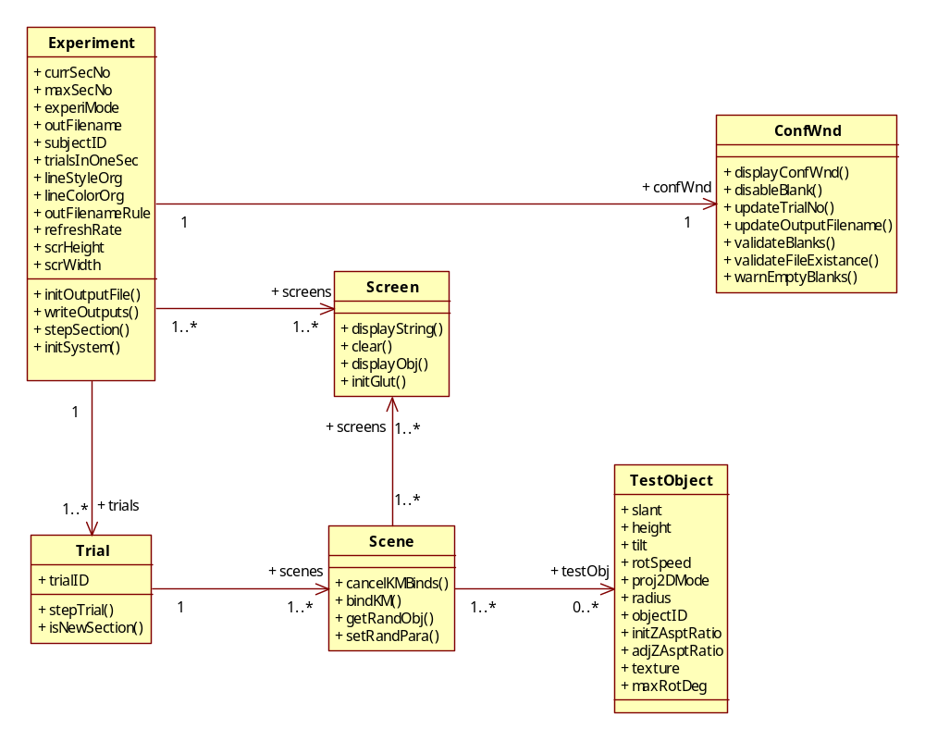

Refined Class diagram
